EDITORIAL NOTE (remove before submission): This chapter reports the student's own real, already-completed AMIRIS experimental work (documented in AMIRIS_Germany2027_Progress_Report.pdf). The prose was drafted by Claude (Anthropic) per the student's explicit authorization, from the project's own verified results and commentary -- no external literature synthesis is involved here, so this chapter falls under the AI-usage policy's 'create texts / data analysis, citation of prompt necessary' category rather than the barred 'summarise state of research' category. Prompt citation: Claude Sonnet 5 (Anthropic), output generated 18 September 2026, session https://claude.ai/code/session_01VmiP7rpUwBmA2YjSGWGxHo. All figures below are taken directly from generate_2027_progress_report.py / AMIRIS_Germany2027_Progress_Report.pdf; none were invented for this draft. The student should review every figure against the source report before submission.

Chapter 3: Methodology and Scenario Construction

3.1 Comparison design and the data-harmonisation principle
This thesis's central task, set out in Chapter 1, is a controlled comparison between AMIRIS and Energy Brainpool for the German day-ahead market in 2027, 2028, and 2029. As Section 2.7 established, a naive comparison of two models' outputs confounds differences in market logic with differences in input assumptions; the identical-input design adopted here is the standard technique in the model-intercomparison literature for isolating the former from the latter. In practice this meant treating Energy Brainpool's own supplied data package as the primary source for every German-side input AMIRIS requires -- demand, conventional generation capacity by fuel, renewable capacity, fuel and carbon prices, and flexible-demand assumptions such as electrolysis and e-mobility -- and filling any remaining gap from independently sourced, real public data, documented explicitly as such rather than silently blended in.
The one substantial gap this principle could not close from Brainpool's own data was the Rest-of-Europe (ROE) side of the market: Germany's day-ahead price cannot be modelled in isolation once cross-border trade is included, yet Brainpool's supplied package does not include the underlying generation, demand, and transmission detail for Germany's neighbours that AMIRIS's own MarketCoupling agent requires. Sourcing and constructing this ROE-side data independently, documented in Sections 3.3 and 3.4 below, is therefore the largest single methodological undertaking this thesis's own empirical work involved.

3.2 The Germany 2027 baseline scenario
The German-side scenario for each comparison year (2027, 2028, 2029) is built directly from Energy Brainpool's own supplied data package for that year, following the same principle already validated in this project's earlier Germany 2023 scenario-construction work (Chapter 1): conventional generation capacity by fuel type, installed renewable capacity, hourly demand, fuel and carbon price paths, and flexible-demand targets (electrolysis, e-mobility) are all taken as genuine, year-specific figures directly from Brainpool's forecast rather than held constant or re-derived. Subsidy reference values (feed-in tariff and market-premium LCOE figures, described in Section 2.5.1) are one documented exception: these are sourced once, from Germany's own real BNetzA-auction figures, and held static across all three comparison years, since no year-specific subsidy projection was available in Brainpool's package. This is a deliberate, stated simplification, not an oversight, and is revisited as a limitation in Chapter 6.

3.3 Constructing the Rest-of-Europe market-coupling zone

3.3.1 Initial coupling and real transmission capacity
The Rest-of-Europe zone was built as a single aggregate market, pooling nine (later ten, once Switzerland's data was added) of Germany's real neighbouring countries into one AMIRIS DayAheadMarketSingleZone coupled to Germany's own market via AMIRIS's MarketCoupling agent, rather than modelling each neighbour as its own separate zone from the outset. Aggregate demand, generation capacity by fuel, and renewable capacity for this pooled zone were sourced from real Eurostat energy-balance statistics for the nine core countries, with Switzerland's own figures backfilled from ENTSO-E where Eurostat coverage was incomplete. Hourly renewable capacity factors were derived from real 2009 weather-year data, consistent with the weather year already used for Germany's own renewable profiles elsewhere in this project. The transmission capacity linking the two zones was derived from real observed ENTSO-E cross-border physical flow data rather than an assumed or nominal figure, using each border's 98th percentile of real hourly flow values as a conservative proxy for available capacity -- a technique reused consistently across every later transmission-capacity figure sourced in this project, including the ERAA-based figures described in Section 3.4.
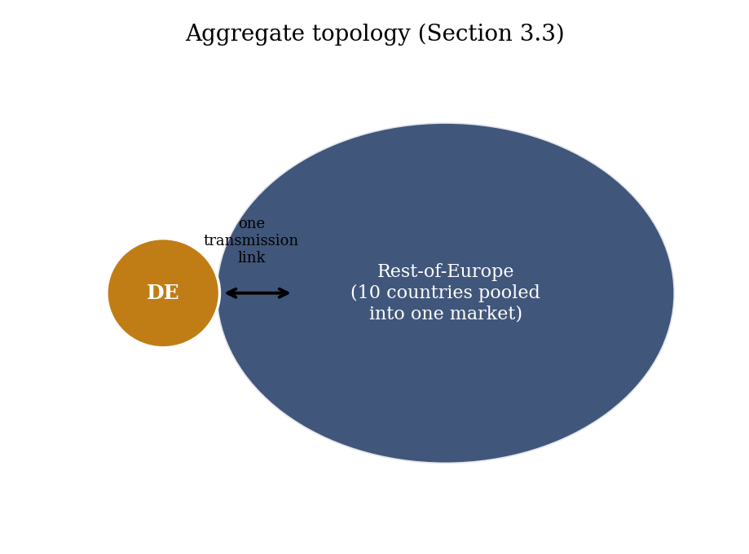
Figure 3.1: The aggregate topology: Germany coupled to a single pooled Rest-of-Europe market via one transmission link (own illustration of this project's own scenario structure).

3.3.2 Storage and subsidy realism: the Phase 37 build
The initial aggregate ROE zone modelled hydropower as a flat-capacity-factor resource and renewable subsidy as an unrealistic zero-feed-in-tariff assumption. Both were replaced with genuinely dispatchable, real-data-grounded representations: the zone's real total hydropower capacity (110,769.3 MW across ten countries, Eurostat) was split into a pumped-storage component and a reservoir-hydro component using a real EU-wide reference ratio (30 per cent pumped storage of total EU hydropower capacity, International Hydropower Association, 2023) and Switzerland's own real ENTSO-E-sourced reservoir-to-run-of-river ratio (90.2:9.8) as the best available real per-technology reference point for the aggregate. The resulting Pumped Storage (33,303.2 MW) and Reservoir Hydro (69,904.1 MW) agents reuse Germany's own calibrated duration, round-trip efficiency, and charge/discharge ratio figures as technology characteristics, on the reasoning that these engineering properties are reasonably similar across countries even where economic scale is not. Only run-of-river hydro (7,562.1 MW) remains a flat-capacity-factor placeholder. Renewable subsidy was correspondingly replaced with a genuine market-premium mechanism using Germany's own real BNetzA-auction-sourced 2026 support levels (52 EUR/MWh onshore and offshore wind, 49 EUR/MWh solar) as the best available real reference for the whole aggregate zone, rather than a per-country subsidy model.
Three genuine AMIRIS configuration issues surfaced and were resolved while building this zone, each confirmed directly by reproducing the resulting error before applying a fix rather than guessed at: a single shared price forecaster cannot serve two zones' storage agents simultaneously (resolved by giving the ROE zone its own dedicated forecaster); AMIRIS's market-premium trader agent cannot administer a feed-in-tariff-based renewable, requiring the separate system-operator trader agent type already used for this purpose in Germany's own zone; and every ROE contract had been implicitly sharing Germany's own forecaster since the zone was first built, a latent inconsistency that only surfaced once ROE's new storage agents required an accurate zone-specific forecast. This resulting build, Germany2027_MarketCoupling_ROEFlex, is the scenario this thesis refers to throughout as its headline result; its results are reported in Chapter 5.

3.4 Extending to 2028 and 2029
The 2027 scenario structure was extended to Germany's other two comparison years by coupling each year's own Brainpool-sourced German data to the same ROE zone. Because no future-year Rest-of-Europe projection existed at the time, the ROE zone's economic size (demand, capacity, transmission capacity) was initially held frozen at its real 2023/2024 snapshot for both years, following this project's established out-of-sample principle of reusing a calibrated mechanism unchanged rather than re-tuning it per year; only each series' hourly shape was redated to match each year's real calendar. This frozen-ROE approach is referred to as the baseline out-of-sample build in Chapters 4 and 5. A later build, described in Section 3.4.1, replaced the frozen snapshot with a real sourced growth trajectory.

3.4.1 A real ERAA-sourced growth trajectory
As reported in Section 5.4, the frozen-ROE assumption was found to be a genuine, increasingly binding limitation as the target year moved further from the 2027 calibration year. A real, sourced alternative was constructed from ENTSO-E's European Resource Adequacy Assessment (ERAA 2024) dataset, described in Section 2.6, covering target years 2026, 2028, 2030, 2032, and 2035; 2029 figures were obtained by log-linear interpolation between the real 2028 and 2030 values. One methodological trap was found and avoided during this build: ERAA reports gross demand (before network losses and self-consumption), a materially different quantity from the net final consumption figures Eurostat reports and this project uses everywhere else; using ERAA's absolute demand figures directly would have introduced a spurious jump of roughly 26 per cent between the 2024 Eurostat baseline and the 2026 ERAA figure. The fix applied only ERAA's internal growth rate, anchored to the real 2024 Eurostat total, so that the definitional difference between the two datasets cancels out rather than being carried into the projection. The same growth-rate-anchoring technique was applied to ERAA's real capacity data by technology and to ERAA's real NTC transmission-capacity data (again using the 98th-percentile convention from Section 3.3.1, this time applied to pre-computed capacity data rather than observed flow). The resulting scenario is referred to as the growth-projected build in Chapter 5.

3.5 Evaluation metrics
Every comparison in this thesis uses the same core set of metrics, computed on the joined hourly AMIRIS and Brainpool price series for the German zone: mean price, mean absolute error (MAE), bias (mean signed error, AMIRIS minus Brainpool), and Pearson correlation. Two further metrics specific to this comparison's structure are used throughout: the shortage-hour count (hours in which AMIRIS's demand agent cannot be fully served, triggering the scarcity-price convention described in Section 2.3.2) and the negative-price-hour share, since both are hours where AMIRIS's and Brainpool's price-formation logic differ most structurally, described further in Section 5.4.
A single methodological refinement, established during this project's earlier single-zone work and retained throughout the market-coupling phases, is reported consistently alongside the headline correlation figure: because AMIRIS's shortage-hour price is capped at an administratively set value substantially higher than any ordinary market price, a small number of shortage hours can dominate the Pearson correlation computed across the full year, producing an all-hours correlation figure that does not reflect how well the model tracks Brainpool's price on the 99-plus per cent of hours that are not genuine scarcity events. Every correlation, bias, and MAE figure in this thesis is therefore reported both across all hours and after excluding shortage hours (the excl-shortage figure), with the excl-shortage figure treated as the primary metric for judging ordinary-hour accuracy and the all-hours figure retained for transparency rather than omitted. Section 5.5 reports one further mechanism, ShortagePriceMethod, that substantially narrows the gap between the two without altering which hours are classified as shortage hours.
This project's standing methodological discipline, applied throughout the phases reported in Chapters 4 and 5, requires every accepted parameter change to carry an independent, real justification established before it is tested, rather than being adjusted to fit the comparison after the fact; changes tested purely to improve a metric, without independent justification, are explicitly excluded from this project's accepted methodology and, where tested anyway as an exploratory check, are reported as such.

